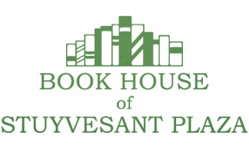
MARGGIE SKINNER’S PICKS
FICTION
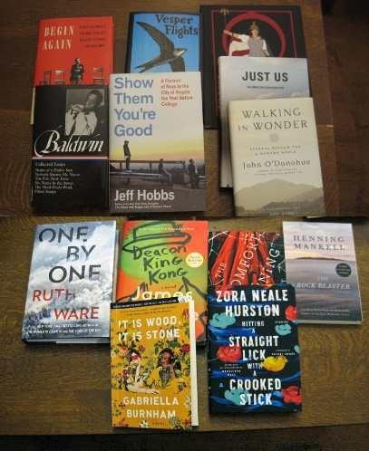
Deacon King Kong -- James Mcbride “Deacon King Kong is a quintessential New York story. Set in the Brooklyn projects in 1969, a perpetually inebriated deacon called Sportcoat aims a gun at the neighborhood’s main drug dealer in the public plaza and pulls the trigger. Incredibly well-constructed and hilarious at times, McBride’s story entwines a number of storylines that are kickstarted by this central event.”
The Mountains Sing -- Nguyen Phan Que Mai- The story of one family’s history in Vietnam through the 20th century. Beautiful writing, powerful story of survival through oppression by the Japanese, French, Chinese and Americans.
One By One – Ruth Ware- Death and adventure atop an icy Alpine mountain. I read this in the heat of July when the cold winds were refreshing. Reading it inside in the winter will probably make you feel warm and cozy, while you are on the edge of your seat.
The Rock Blaster - Henning Mankell- Mankell’s first novel, pre the Wallender mysteries, tells the story of Scandinavian strength, resilience and stoicism..
The Discomfort Of Evening - Marieke Lucas Rijneveld- Winner International Booker Prize 2020- Highly recommended by Bert Fay- “ a tender and visceral evocation of a childhood caught between shame and salvation” Not for the faint of heart.
It Is Wood It Is Stone - Gabriella Burnham- An American professor’s sabbatical in Sao Paolo is transformative for him and his wife. As a reader, the book left me with a deeper way of thinking about the people we are and the people whose lives we touch.
Hitting A Straight Lick With A Crooked Stick - Zora Neale Hurston- A wonderful collection of short stories that will make you laugh, make you cry and make you so happy that these stories were preserved and published for us for today.

NON FICTION
Show Them You’re Good - Jeff Hobbs- I admit, I was overwhelmed by Hobbs’ first book, The Short and Tragic Life of Robert Peace- if you never read it- do it now. For this book, Hobbs spent a year with high school seniors in 2 schools in LA- Animo Pat Brown Charter High School and Beverly Hills High. The stories break your heart and inspire. Thank you for doing this, Jeff.
Continued
Good Books for Good Works 2020 – Book House Staff Recommendations 2

We Demand The Right To Vote- Meneese Wall- Step by step, woman by woman, one more book about the struggle for women’s suffrage laid out in a beautiful book for you to share with your sisters, your daughters, your parents, everyone.
Just Us An American Conversation -- Claudia Rankine- As promised, a calm, reasoned conversation about racism between each reader and the author. Sit back and listen.
Walking In Wonder- John O’Donohue A collection of conversations and radio presentations from O’Donohue that will feed your spiritual hunger.
Library Of America’s James Baldwin Collected Essays- still relevant- maybe even more relevant today- may be combined with Begin Again- Eddie Glaude Jr. – a commentary of Baldwin’s America and its urgent lessons for today.
Vesper Flights -- Helen Macdonald- A collection of essays about the human relationship to the natural world.

SUSAN TAYLOR’S PICKS
One Life--Megan Rapinoe--for the women's soccer fan in your life!
Red Comet--Heather Clark--the newest biography of Sylvia Plath tears away the myths and restores her intellectual merits and her lifelong ambition
Hench--Natalie Zina Walschots--after Anna is injured in an episode in which a super-hero causes enough collateral damage to leave her limping for life, she is determined to use her skills as a data technician to show how much damage the "good guys" leave in their wake and to make them the bad guys. Hilarious & thought provoking!
Nobody Ever Asked Me About the Girls--Lisa Robinson-- a woman rock journalist in the male-dominated music world writes about famous female rock stars--fascinating & infuriating
Agent Sunya--Ben MacIntyre--espionage expert MacIntyre portrays another brilliant spy, this one a German woman who fought fascism from before World War II through the Cold War
Ready Player Two--Ernest Cline--this goes on sale on Tuesday, 11/24--the sequel to Ready Player One. I can't WAIT to read it!
The City We Became--NK Jemisin--a love letter to New York City enclosed in a fantasy novel in which the city and its boroughs have avatars that must fight an evil force that wants to destroy it. (While reading it, I envisioned COVID-19 as the evil force.) Stunning!
The House in the Cerulean Sea--TJ Klune--a charming fable about a by-the-book children's service caseworker who goes to inspect a foster home for magical children that might be going beyond the rules and regulations. A beautiful tale about love & family.
The Midnight Library--Matt Haig--when Nora decides to commit suicide, before her actual death she is confronted by a mysterious library, in which all of her possible existences are still viable, provided she made different choices in her lifetime. As she moves from one life to the next, she begins to understand what she is actually looking for--a great read!
Rodham--Curtis Sittenfeld--the fictional life of Hillary Rodham if she had decided not to marry Bill Clinton. Well-written, entertaining what-if scenario--I loved it!
Squeeze Me--Carl Hiaasen--a hilarious take on West Palm Beach and the charity industry that fuels its social life. Features the President (code named "Mastodon"), the First Lady, greedy heirs, and murderous jewel thieves, plus the non-native pythons that keep turning up to ruin the charity galas. So funny!
The Thursday Murder Club--Richard Osman--if you think folks in retirement homes spend their time watching television and zoning out, you haven't met the Thursday Murder Club! A clever mystery set in Agatha Christie territory--delightful!
Utopia Avenue--David Mitchell--Utopia Avenue is a band born in 1967 whose rise to fame and stardom affects each band member in different ways; the members' backstories and the relationships within the band make this a perfect novel for a music nerd. Has links to Mitchell's previous novels, but you don't have to have read any of them to enjoy this one.
Continued
Good Books for Good Works 2020 – Book House Staff Recommendations 3

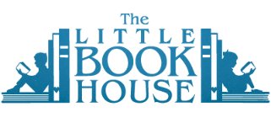
KATHLEEN CAREY'S KID PICKS

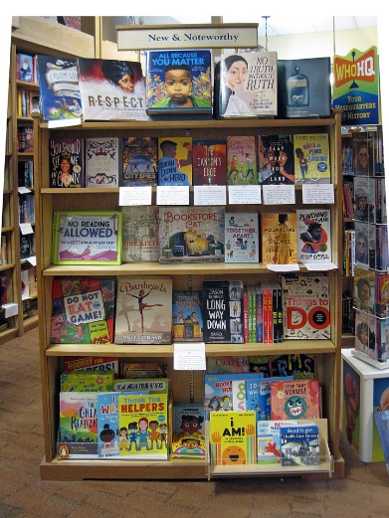
Note: Some of these titles are on display in the “New and Noteworthy” section of the Little Book House near the back of the store on the left.
PICTURE BOOKS:
One Little Bag: An Amazing Journey -- Henry Cole
The Barnabus Project -- The Fan Brothers
All Because You Matter -- Tami Charles
Do Not Eat The Game -- Matthew McElligott

Bunheads -- Misty Copeland
The Bookstore Cat -- Cylin Busby
No Reading Allowed -- Raj Haldar

MIDDLE READERS -- Ages 9-14:
Canyon's Edge -- Dusti Bowling
The Queen Bee and Me -- Gillian McDunn
Isaiah Dunn is My Hero -- Kelly J. Baptist
Ways To Make Sunshine -- Renee Watson
City Spies -- James Ponti

GRAPHIC NOVELS -- Ages 9-14
The Big Break -- Mark Tatulli
When Stars Are Scattered -- Victoria Jamieson & Omar Mohamed
Long Way Down -- Jason Reynolds
Nat Enough -- Maria Scriven
Stepping Stones -- Lucy Knisley

YOUNG ADULT -- Ages 14+
Clap When You Land -- Elizabeth Acevedo
The Fountains of Silence -- Ruta Sepetys
Punching The Air -- Ibi Zoboi & Yusef Salaam
You Should See Me in a Crown -- Leah Johnson
Among the Beasts & Briars -- Ashley Poston
Together, Apart -- A short story collection for our times

THE BEST OF THE REST:
The Highlights Book of Thing to Do
Skunk and Badger
The Big, Fun Kids Cookbook -- Food Network
Anatomicum -- Welcome to the Museum
Pierre the Maze Detective: The Curious Case of the Castle in the Sky -- Hiro Kamigaki
Harry Potter & the Sorcerer's Stone: The Minalima Edition
No Truth Without Ruth: The Life of RBG -- Kathleen Krull
R-E-S-P-E-C-T: Aretha Franklin, the Queen of Soul -- Carole Boston Weatherford
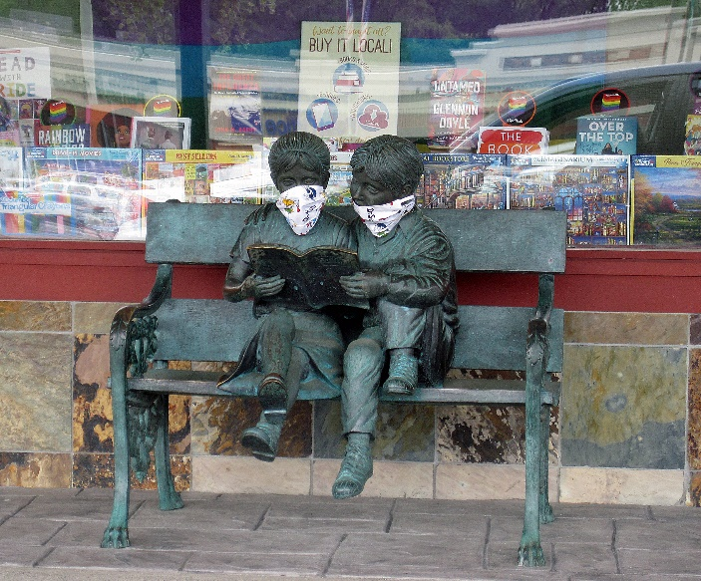
BOXED SETS!

